**Personal Finance Tracking Web Application**

**Author (s): ____Nihar Shukla, Andrew Quinn__ Date: __10/6/2024_____**

**Version: ____1_______**

User Stories:

1. As a user, I want to create an account, so that I can access my financial tracking information.

2.As a user, I want to add my income and expenses, so that I can track my monthly and yearly financial activities.

3.As a user, I want to see my financial data represented in graphs, so that I can easily understand my financial patterns

4.As a user, I want to categorize my income and expenses, so that I can understand where I am earning/spending money

5.As a user, I want to import and export my financial data, so that I can back it up and transfer it between services when needed.

User Case Diagram:

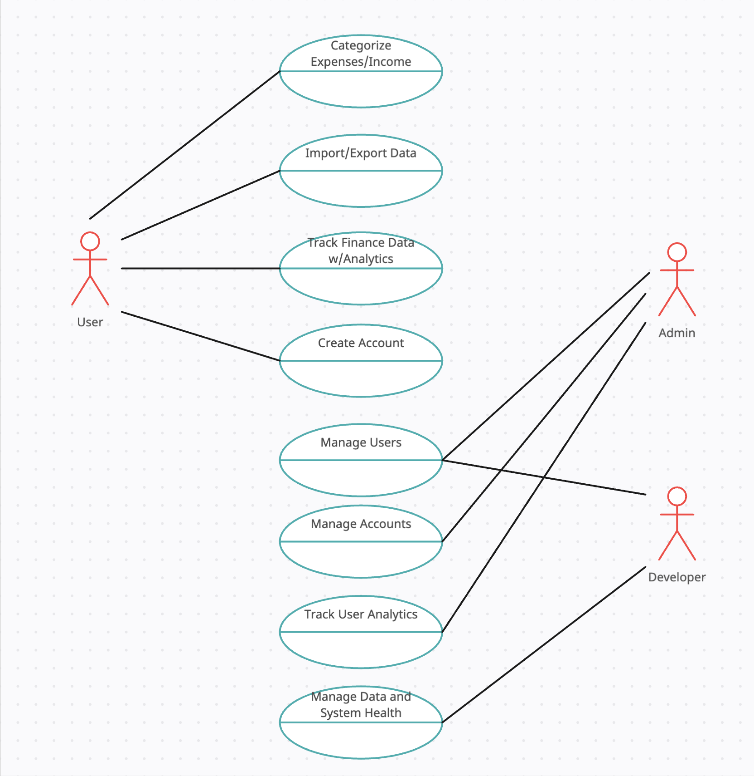

| **USE CASE NAME:** | User Registration | | **USE CASE TYPE** |
| --- | --- | --- | --- |
| **USE CASE ID:** | UC-01 | | Business Requirements: **□** |
| **PRIORITY:** | High | | System Analysis:□ |
| **SOURCE:** | User Story 1 | | System Design: **🗹** |
| **PRIMARY BUSINESS ACTOR** | User | | |
| **PRIMARY SYSTEM ACTOR** | Personal Finance Tracking Web Application | | |
| **OTHER PARTICIPATING ACTORS:** | * N/A | | |
| **OTHER INTERESTED STAKEHOLDERS:** | * N/A | | |
| **DESCRIPTION:** | A user wants to create an account for the web application to store financial information | | |
| **PRE-CONDITION:** | User is connected to the internet and on the Sign-Up Form | | |
| **TRIGGER:** | User submits the sign-up form | | |
| **TYPICAL COURSE** | **Actor Action** | **System Response** | |
| **OF EVENTS:** | **Step 1**: User clicks on the Sign Up button | **Step 2**: System displays the sign-up form | |
|  | **Step 3:** User enters name, email and password | **Step 4:** System validates all information was entered and no account exists for the email | |
|  | **Step 5:** User submits the form | **Step 6:** System creates the user's account and stores it in the database. System redirects the user to the landing page. | |
|  |  |  | |
|  |  |  | |
|  |  |  | |
|  |  |  | |
|  |  |  | |
| **ALTERNATE COURSES:** | User enters an existing email address. System prompts that an account already exists. | | |
|  | User does not fill out all fields. System prompts that all fields must be filled out. | | |
|  | User does not enter the correct email format. System prompts that email form must be correct. | | |
|  |  | | |
|  |  | | |
|  |  | | |
|  |  | | |
|  |  | | |
| **CONCLUSION:** | User is able to sign up and have an account created in the system | | |
| **POST-CONDITION:** | User is redirected to the landing page with successful signup. | | |
| **BUSINESS RULES** | * User must fill out all required forms to sign up * User cannot have multiple accounts under one email address | | |
| **IMPLEMENTATION CONSTRAINTS AND SPECIFICATIONS** | * Email must be parsed to make sure it doesn’t exist in the database * Passwords must be stored in encrypted format | | |
| **ASSUMPTIONS:** | * User does not have a pre-existing account/email address in the system. | | |
| **OPEN ISSUES:** | N/A | | |

| **USE CASE NAME:** | Adding income and expenses | | **USE CASE TYPE** |
| --- | --- | --- | --- |
| **USE CASE ID:** | UC-02 | | Business Requirements: **□** |
| **PRIORITY:** | High | | System Analysis:□ |
| **SOURCE:** | User Story 2 | | System Design: **🗹** |
| **PRIMARY BUSINESS ACTOR** | User | | |
| **PRIMARY SYSTEM ACTOR** | Personal Finance Tracking Web Application | | |
| **OTHER PARTICIPATING ACTORS:** | * N/A | | |
| **OTHER INTERESTED STAKEHOLDERS:** | * N/A | | |
| **DESCRIPTION:** | A user wants to enter their income and expense information for tracking and storage | | |
| **PRE-CONDITION:** | User is logged into their account and on the Income/Expenses page | | |
| **TRIGGER:** | User inputs income or expense into the appropriate field and submits the form | | |
| **TYPICAL COURSE** | **Actor Action** | **System Response** | |
| **OF EVENTS:** | **Step 1**: User clicks on Income/Expenses page | **Step 2**: System navigates the user to the page if user is signed in or redirects to login page | |
|  | **Step 3:** User enters income and expenses details in the form | **Step 4:** System validates the fields | |
|  | **Step 5:** User submits the form | **Step 6:** System stores the information in the database under the users account | |
|  |  |  | |
|  |  |  | |
|  |  |  | |
|  |  |  | |
|  |  |  | |
| **ALTERNATE COURSES:** | User attempts to submit the form without filling out appropriate fields. System prompts users to fill out all fields required. | | |
|  | User attempts to input information in the wrong format. System will prompt user to fix the formatting in the field. | | |
|  |  | | |
|  |  | | |
|  |  | | |
|  |  | | |
|  |  | | |
|  |  | | |
| **CONCLUSION:** | Users income/expenses are uploaded to the database and added to their profile | | |
| **POST-CONDITION:** | User’s financial information is updated with new income/expenses | | |
| **BUSINESS RULES** | * User must be logged in and data must get stored securely on MongoDB | | |
| **IMPLEMENTATION CONSTRAINTS AND SPECIFICATIONS** | * Data must be securely stored and linked to the user using their unique identifier(email) | | |
| **ASSUMPTIONS:** | * Information entered by users is accurate | | |
| **OPEN ISSUES:** | N/A | | |

| **USE CASE NAME:** | Financial Patterns | | **USE CASE TYPE** |
| --- | --- | --- | --- |
| **USE CASE ID:** | UC-03 | | Business Requirements: **□** |
| **PRIORITY:** | Medium | | System Analysis:□ |
| **SOURCE:** | User Story 3 | | System Design: **🗹** |
| **PRIMARY BUSINESS ACTOR** | User | | |
| **PRIMARY SYSTEM ACTOR** | Personal Finance Tracking Web Application | | |
| **OTHER PARTICIPATING ACTORS:** | * N/A | | |
| **OTHER INTERESTED STAKEHOLDERS:** | * N/A | | |
| **DESCRIPTION:** | Users want to view graphical summaries based on their information to view financial patterns | | |
| **PRE-CONDITION:** | User is logged into their account and has income/expenses uploaded to their profile | | |
| **TRIGGER:** | User opens the Financial Patterns page within the application | | |
| **TYPICAL COURSE** | **Actor Action** | **System Response** | |
| **OF EVENTS:** | **Step 1**: User clicks on Financial Patterns page | **Step 2**: System navigates the user to the page if user is signed in or redirects to login page | |
|  |  | **Step 3:** System generates graphs and presents them to the user based on their information | |
|  |  |  | |
|  |  |  | |
|  |  |  | |
|  |  |  | |
|  |  |  | |
|  |  |  | |
| **ALTERNATE COURSES:** | Users do not have existing data for their profile. System informs user no data exists and shows “Add Data” button to redirect user to Income/Expenses page | | |
|  |  | | |
|  |  | | |
|  |  | | |
|  |  | | |
|  |  | | |
|  |  | | |
|  |  | | |
| **CONCLUSION:** | System displays graphical data and summary to user | | |
| **POST-CONDITION:** | User is able to view their financial graphs | | |
| **BUSINESS RULES** | * Graphs must be parsed based on users existing income/expenses information | | |
| **IMPLEMENTATION CONSTRAINTS AND SPECIFICATIONS** | * Data must be displayed through proper data visualization tools and be legible | | |
| **ASSUMPTIONS:** | * User has pre-existing financial data and is logged in | | |
| **OPEN ISSUES:** | N/A | | |

| **USE CASE NAME:** | Income/Expense Categorization | | **USE CASE TYPE** |
| --- | --- | --- | --- |
| **USE CASE ID:** | UC-04 | | Business Requirements: **□** |
| **PRIORITY:** | High | | System Analysis:□ |
| **SOURCE:** | User Story 4 | | System Design: **🗹** |
| **PRIMARY BUSINESS ACTOR** | User | | |
| **PRIMARY SYSTEM ACTOR** | Personal Finance Tracking Web Application | | |
| **OTHER PARTICIPATING ACTORS:** | * N/A | | |
| **OTHER INTERESTED STAKEHOLDERS:** | * N/A | | |
| **DESCRIPTION:** | Users want to be able to categorize their expenses/income within the application | | |
| **PRE-CONDITION:** | User is logged into the application and has sufficient permissions to edit their expenses/income | | |
| **TRIGGER:** | User clicks on dropdown next to expense/income | | |
| **TYPICAL COURSE** | **Actor Action** | **System Response** | |
| **OF EVENTS:** | **Step 1**: User clicks on dropdown next to expense/income | **Step 2**: System displays list of expense/income types (dependent on whether expense or income) | |
|  | **Step 3:** User clicks on a type in the dropdown menu | **Step 4:** Income/expense is categorized under the selected type and the type is displayed in the dropdown. In the DB, the category is associated with this expense/income so it persists between sessions.. | |
|  |  |  | |
|  |  |  | |
|  |  |  | |
|  |  |  | |
|  |  |  | |
|  |  |  | |
| **ALTERNATE COURSES:** | If the user clicks outside of the dropdown menu when the menu is open instead of selecting a category, the dropdown menu will close. | | |
|  | If an item is already categorized, the selection of a 2nd category will unselect the first. | | |
|  |  | | |
|  |  | | |
|  |  | | |
|  |  | | |
|  |  | | |
|  |  | | |
| **CONCLUSION:** | The user is able to categorize their expenses and income. | | |
| **POST-CONDITION:** | The dropdown menu shows the category of the expense/income and the type is saved in the database to persist between sessions. | | |
| **BUSINESS RULES** | * User should be limited to selecting one category per expense/income item | | |
| **IMPLEMENTATION CONSTRAINTS AND SPECIFICATIONS** | * User permissions should be validated prior to allowing the user to access this item. | | |
| **ASSUMPTIONS:** | * User has sufficient permissions to access and edit the income/expense item. | | |
| **OPEN ISSUES:** | N/A | | |

| **USE CASE NAME:** | Import/Export Financial Data | | **USE CASE TYPE** |
| --- | --- | --- | --- |
| **USE CASE ID:** | UC-05 | | Business Requirements: **□** |
| **PRIORITY:** | High | | System Analysis:□ |
| **SOURCE:** | User Story 5 | | System Design: **🗹** |
| **PRIMARY BUSINESS ACTOR** | User | | |
| **PRIMARY SYSTEM ACTOR** | Personal Finance Tracking Web Application | | |
| **OTHER PARTICIPATING ACTORS:** | * User operating system | | |
| **OTHER INTERESTED STAKEHOLDERS:** | * N/A | | |
| **DESCRIPTION:** | Users should have the ability to import and export their financial data, so that they can back it up and transfer it between services when needed. | | |
| **PRE-CONDITION:** | User must be signed in and validated | | |
| **TRIGGER:** | User clicks the import/export button | | |
| **TYPICAL COURSE** | **Actor Action** | **System Response** | |
| **OF EVENTS:** | **Step 1**: User selects export option | **Step 2**: Application opens a prompt through their operating system allowing the user to choose where to save the output | |
|  | **Step 3:** User selects a file location in their OS | **Step 4:** Application generates an Excel output file from the user’s data and sends it to the user where it is saved at the specified location. | |
|  |  |  | |
|  |  |  | |
|  |  |  | |
|  |  |  | |
|  |  |  | |
|  |  |  | |
| **ALTERNATE COURSES:** | Users can cancel the process at any point by canceling the prompt within their OS or clicking outside of the menu in the application. | | |
|  | If the user selects import instead of export, a similar prompt will open allowing the user to select an existing Excel file in their OS to import. The application will then attempt to import it and validate the input. If the input is in the correct format, the import will proceed, otherwise it will fail. Any imported data will be displayed on the user’s page once completed. | | |
|  |  | | |
|  |  | | |
|  |  | | |
|  |  | | |
|  |  | | |
| **CONCLUSION:** | Data should be able to be imported/exported by the user at will. | | |
| **POST-CONDITION:** | Either the data is imported (or an error is thrown if the import file is in the incorrect format) or the data is exported and saved locally for the user depending on their selection | | |
| **BUSINESS RULES** | * User data should be updated within the UI immediately after data import is complete * User access must be validated immediately prior to import/export | | |
| **IMPLEMENTATION CONSTRAINTS AND SPECIFICATIONS** | * As this is a sensitive operation, user validation should occur immediately prior to the import/export procedure to ensure the validity of the operation. | | |
| **ASSUMPTIONS:** | * User is logged in | | |
| **OPEN ISSUES:** | N/A | | |